**DECIMAL TO OCTAL CONVERSION**  
**EXP NO: 29**  
**AIM:**To write a C program to implement decimal to octal conversion.  
**ALGORITHM:**  
1)      Store the remainder when the number is divided by 8 in an array.  
2)      Divide the number by 8 now  
3)      Repeat the above two steps until the number is not equal to 0.  
4)      Print the array in reverse order now.  
**PROGRAM:**  
  
  
#include  
<stdio.h>  
  
  
int  
main()  
  
  
{  
  
  
    long decimal, remainder, quotient,octal=0;  
  
  
    int octalnum[100], i = 1, j;  
  
  
    printf("Enter the decimal number:  
");  
  
  
    scanf("%ld", &decimal);  
  
  
    quotient = decimal;  
  
  
    while (quotient != 0)  
  
  
    {  
  
  
        octalnum[i++] = quotient % 8;  
  
  
        quotient = quotient / 8;  
  
  
    }  
  
  
    for (j = i - 1; j > 0; j--)  
  
  
        octal= octal*10 + octalnum[j];  
  
  
    printf("Equivalent octal value of  
decimal no %d is: %d  ",  
decimal,octalnum);  
  
  
    return 0;  
  
  
}  
  
**INPUT:**  
  
  
  
  
  
  
  
  
**OUTPUT:**  
  
  
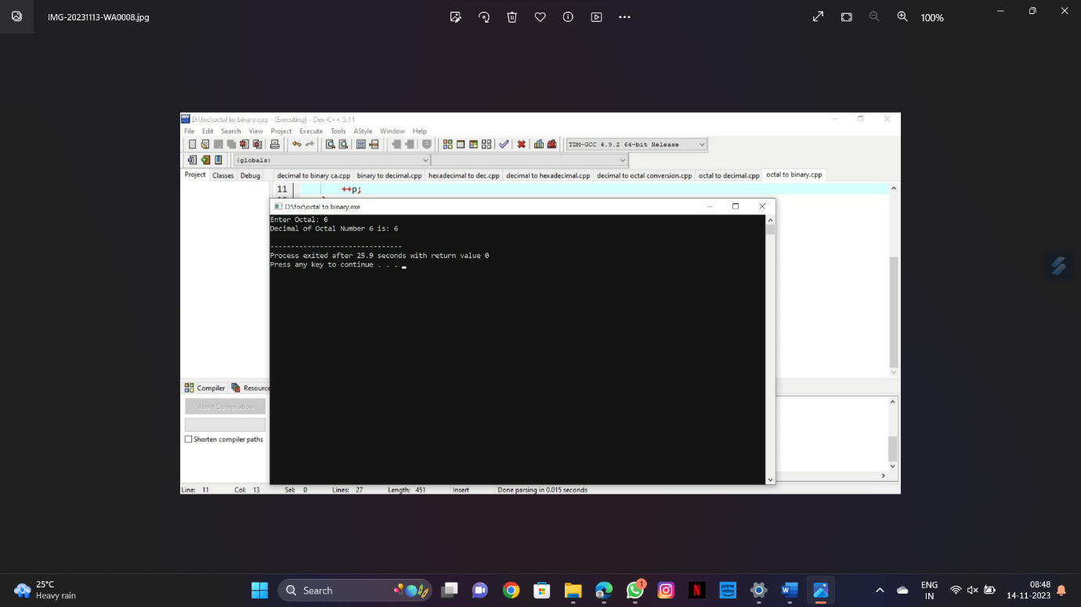  
  
  
**RESULT:**Thus the program was executed successfully using DevC++.